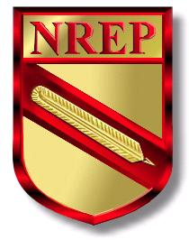
BE PART OF MAKING NREP GROW

The National Registry of Environmental Professionals (NREP) would like to invite you to become actively involved in helping to develop and promote environmental professionalism and certifications. Joining one of the following NREP committees will offer you an opportunity to facilitate improvement and progress within our organization. Please check which of the following committees most interests you. Your form will be sent to that committee to be reviewed and, once approved, you will receive your standing within the committee. The committee meetings are hosted by conference call or webchat and are mandatory for ALL committee members. NREP committees will provide an opportunity for you to network with other environmental professionals, while also having a hand in influencing NREP’s future.

Committees:
- Policies & Procedures
- Standards of Practice Development
- Exams
- Publications
- Awards & Recognition
- Elections & Appointments
- Professional Practice & Ethics (Limited to 15 Members)
- Proficiency Maintenance Review (Limited to 15 Members)
- Legislative Action
- Universities & College Liaison
- Government Liaison
- Industries Liaison
- Student Chapter Development
- Public Relations
- New Applicant Relations

Name: _________________________________________________________
Certification Type & Number: _______________________________________
Company: _______________________________________________________
Street Address: ___________________________________________________
City: ______________________ State: ____ Zip Code: ___________________
Phone: ____________________________ Fax: _________________________
Email: __________________________________________________________

PLEASE RETURN THIS FORM TO:

NREP
P.O. BOX 2099 Glenview, IL 60025

OR

EMAIL: CUSTOMERSERVICE@NREP.ORG

